Spring 2026 University of Delaware
CHEG/ CISC/ ECEG/ MSEG 848
COMPUTING & DATA SCIENCE FOR SOFT MATERIALS INNOVATION
Project Title: Modeling Antioxidant Reactivity with Alkoxy and Peroxyl Radicals
Company: Arkema
Contact for this project:
Brian Koo, Research Scientist
Aanish Paruchuri, Data Scientist
Contact email: brian.koo@arkema.com, aanish.paruchuri@arkema.com

Motivation for this project:
Arkema, a leader in Specialty Materials – Building on its unique set of expertise in materials science, Arkema designs materials to address the ever-growing demand for innovative and sustainable materials, driven by the challenges of new energies, new technologies, the depletion of resources, mobility, and increasing urbanization. The Group is structured into three coherent and complementary segments dedicated to Specialty Materials (Adhesive Solutions, Advanced Materials, and Coating Solutions) accounting for 92% of its sales, and an Intermediates segment leveraging competitive and global product lines. Sustained by the collective energy of its 21,150 employees, Arkema operates in 55 countries and reports sales of €9.5 billion.
The project focuses on the development of advanced heat stabilizers used to prevent thermo-oxidative degradation during polymer processing. Heat stabilizers are added to polymer formulations to allow manufacturers to process polymers at higher temperatures and higher throughput without affecting color, defect-rate, and generation of volatile organic carbons. Good candidate heat stabilizers must deliver high radical scavenging activity, while meeting strict criteria for compatibility with the polymer resin and co-stabilizers and exhibit low extractability and low volatility.
Traditional methods to select good heat stabilizers involve iterating through multiple design, synthesis, and testing cycles, where the experimentation takes time. We have the opportunity to rationally design new heat stabilizers using a data driven approach. There exist extensive kinetic studies going back several decades across industries providing data on radical reactivity with antioxidant molecules in aqueous and non-aqueous fluid solutions across reaction mechanisms, pH environments, and temperatures. We have built a reactivity model for the hydroxyl radical (OH) trained on a limited dataset that we would like to expand to alkoxy and peroxyl radicals, which are more representative of products of polymer degradation.

Project objective:
In this project, Arkema will provide scientific references and relevant databases, and existing data on the relative activity of various antioxidants under a variety of different chemical environments. The team will work to build predictive models using data driven techniques to quantify and rank existing and new antioxidants.

Stages of technical tasks:
- Stage 1. Organize available kinetic data into clear, well-defined categories to assess data coverage and facilitate model training.
- Stage 2. Train and validate a machine learning model to predict the radical scavenging rates of pairs of antioxidants and radicals. Construct multiple models if necessary.

Expected deliverables
- An assessment of available radical scavenging rate data, including chosen categories
- A model or a collection of sub-models predicting radical scavenging rates

Technical skills and knowledge needed for tackling this project: (please select from examples below or add any new phrases that you think is appropriate)
Data-driven modeling, computer programming, data engineering & preprocessing, machine learning modeling, feature engineering

Additional comments:
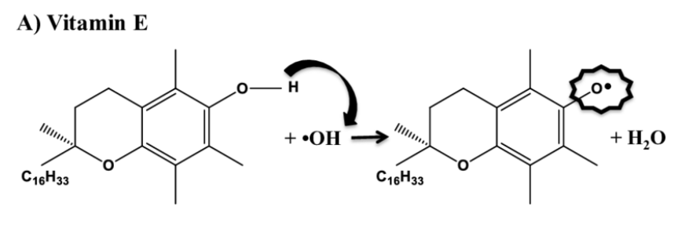
Figure 1. Example of antioxidant radical scavenging behavior (Vitamin E)

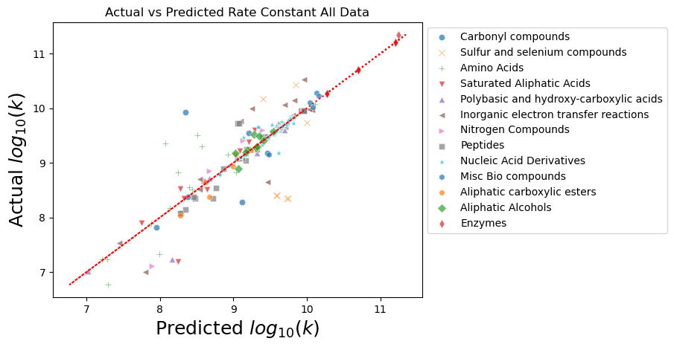
Figure 2. Machine learning predicted antioxidant reaction rates with the hydroxyl radical (OH), model trained during the UDel NRT Spring 2025 course

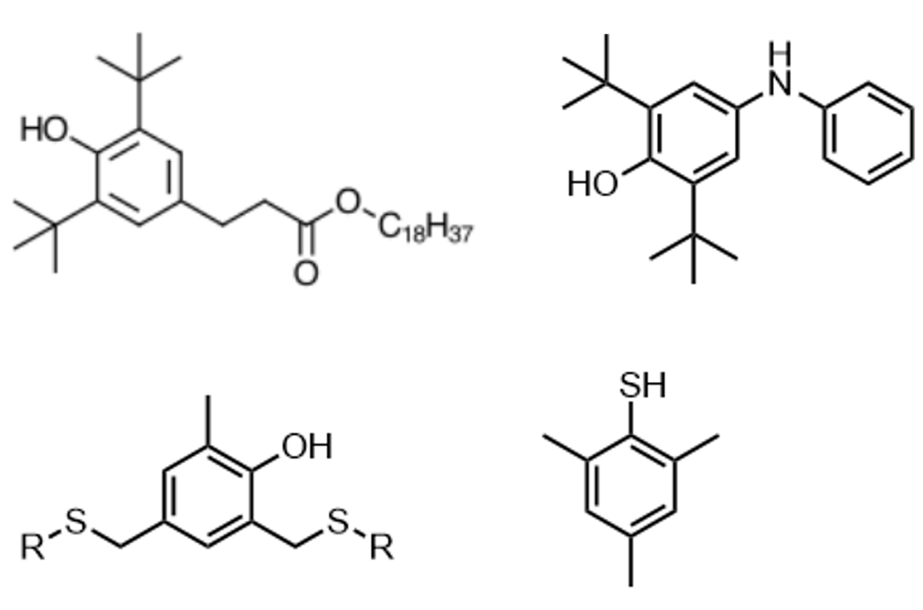
Figure 3. Examples of antioxidants that could be evaluated with the model

